* Smart traffic lights adjust the timing of red and green lights, as well as “walk” and “don’t walk” signs to more efficiently regulate the flow of traffic and pedestrians through an intersection.
* Smart traffic lights use data from sensors, cameras, GPS, vehicles, cell phones and other devices to detect patterns of traffic and the volume of vehicles, pedestrians and bicyclists approaching an intersection.
* By dynamically responding to real-time conditions, smart traffic lights can help move traffic through the city more efficiently to reduce commute times, reduce congestion, minimize carbon emissions and improve safety for drivers, pedestrians and bicyclists.

Smart traffic lights are quickly growing in popularity as urban traffic conditions continue to worsen. Fast population growth and an influx of vehicles and pedestrian traffic have resulted in a steady rise of travel times and congestion as well as a greater number of accidents. Smart traffic lights can help to alleviate these problems by more efficiently moving traffic through intersections. But exactly how do smart traffic lights work, and what are the benefits that they offer to cities and citizens? This short introduction, “How do smart traffic lights work?”, is designed to provide a brief overview of this topic.

How do smart traffic lights work?

Smart traffic lights are one of many smart city initiatives that use advanced technology to improve the management of city services and the quality of life for citizens. Along with smart street lights and smart parking technology, smart traffic lights are helping to create a more intelligent traffic management system that enables smart cities to reduce congestion and travel times, to improve safety and to reduce carbon emissions.

Smart traffic lights use a variety of technologies to dynamically change traffic signals at intersections in response to real-time traffic patterns and weather conditions. Technology used by smart traffic lights may include:

* Sensors and cameras that detect volume and velocity of approaching traffic.
* Devices embedded in vehicles that communicate with traffic lights at intersections as vehicles approaches.
* GPS technology in cell phones that helps smart traffic lights detect and monitor approaching vehicles, bicyclists and pedestrians.
* Sensors that detect weather conditions and air quality.

How do smart traffic lights work to reduce traffic?

Smart traffic lights react to changing traffic patterns in real time, adjusting the length of green lights or red lights at intersections to move traffic more efficiently throughout the city. Smart traffic lights can give priority to buses and streetcars, encouraging citizens to use public transportation that helps reduce vehicle congestion.

How do smart traffic lights work to protect pedestrians?

Smart traffic lights can sense the presence of pedestrians and bicyclists, alerting drivers to their presence and/or stopping traffic to allow time to cross an intersection. Smart traffic lights may also track the progress of a pedestrian or wheelchairs as they cross an intersection, holding the light for an extra period of time when someone needs more time to cross.

How do smart traffic lights work to support emergency response vehicles?

Smart traffic lights enable emergency response vehicles to arrive more quickly at a destination by dynamically changing traffic signals to keep traffic flowing on the route to the emergency and by blocking cars from entering certain intersections before first responders have passed through.

How do smart traffic lights work to limit carbon emissions?

Smart traffic lights help lesson carbon emissions by reducing the amount of time cars must spent idling at red lights. Idling cars are a significant source of greenhouse emissions, generating as much as 30 million tons of carbon dioxide each year, according to the U.S. Department of Energy.

How do smart traffic lights work to improve roadway safety?

Smart traffic lights can help to increase safety on city streets by reducing driver frustration that can lead to distracted or aggressive driving, by adapting signaling to accommodate difficult weather conditions, and by better managing the flow of vehicles, pedestrians and bicycles through intersections.

How do smart traffic lights work with help from Spectrum Enterprise?

Spectrum Enterprise provides a two-way, fully interactive digital network that serves as the connectivity foundation for smart city and smart street initiatives. Spectrum offers symmetrical Internet speeds of up to 100 Gbps that provide cities with the speed and bandwidth they require to transmit and process vast amounts of sensor data. Spectrum also offers gigabit connections for homes and businesses, thousands of WiFi hotspots that will soon be capable of wireless speeds of 1 Gbps, and one of the nation’s largest LTE cellular networks.

Although most traffic lights have a similar appearance, they can often function in very different ways. The most common traffic lights work on simple timers. Depending upon traffic levels at a particular intersection, the traffic light will cycle through green, yellow, and red at regular intervals to ensure a [consistent](https://wonderopolis.org/wonder/how-does-a-traffic-light-work) [flow](https://wonderopolis.org/wonder/how-does-a-traffic-light-work) of traffic in all directions through the intersection. Timer-based systems are excellent for busy areas that have a [consistent](https://wonderopolis.org/wonder/how-does-a-traffic-light-work), heavy volume of traffic.

In areas where traffic can be sporadic and unpredictable, timer-based systems don't work as well. For example, in a rural area, a timer-based system might have drivers stopped unnecessarily when no traffic is present. In these situations, sensor-based traffic signals maximize traffic efficiency by only functioning when traffic is present.

Rather than timers, "smart" or "intelligent" sensor-based traffic signals rely upon a system of sensors to detect when vehicles are present. The types of sensors used can vary by location and technology. Some systems use lasers, rubber hoses filled with air, or video cameras to detect the presence of cars.

Another popular type of sensor is known as an inductive loop system. These systems rely upon a coil of wire embedded in the road's surface. The wire detects changes in magnetic fields when vehicles (large metal objects!) are stopped above them.

So how do sensor-based systems maximize traffic efficiency? In a rural area, for example, the main direction of travel can remain on green to allow the majority of vehicles to pass through quickly. When a vehicle on a side road arrives at the intersection, a sensor will detect it and cycle the lights to allow traffic on the side road to pass through. In this way, traffic can [flow](https://wonderopolis.org/wonder/how-does-a-traffic-light-work) uninterrupted on the main road unless and until traffic on a side road appears.

Some traffic signals in large cities are even advanced enough to allow certain types of vehicles to control them when necessary to allow quick passage through intersections for certain types of vehicles. These systems, known as traffic preemption systems, allow emergency vehicles, such as ambulances, fire trucks, and police cars, to change traffic signals as they approach, so that they can get to where they need to go much faster

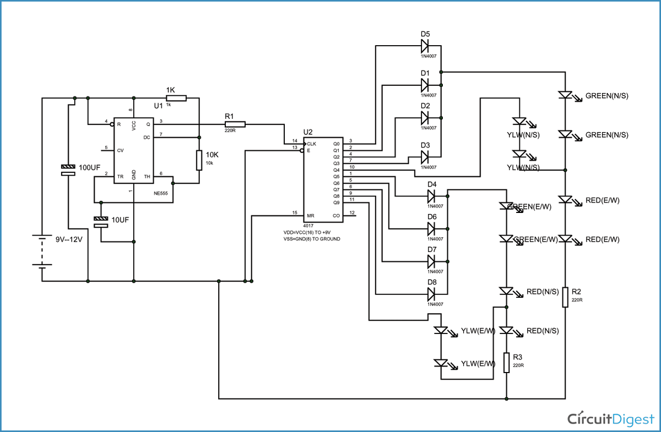

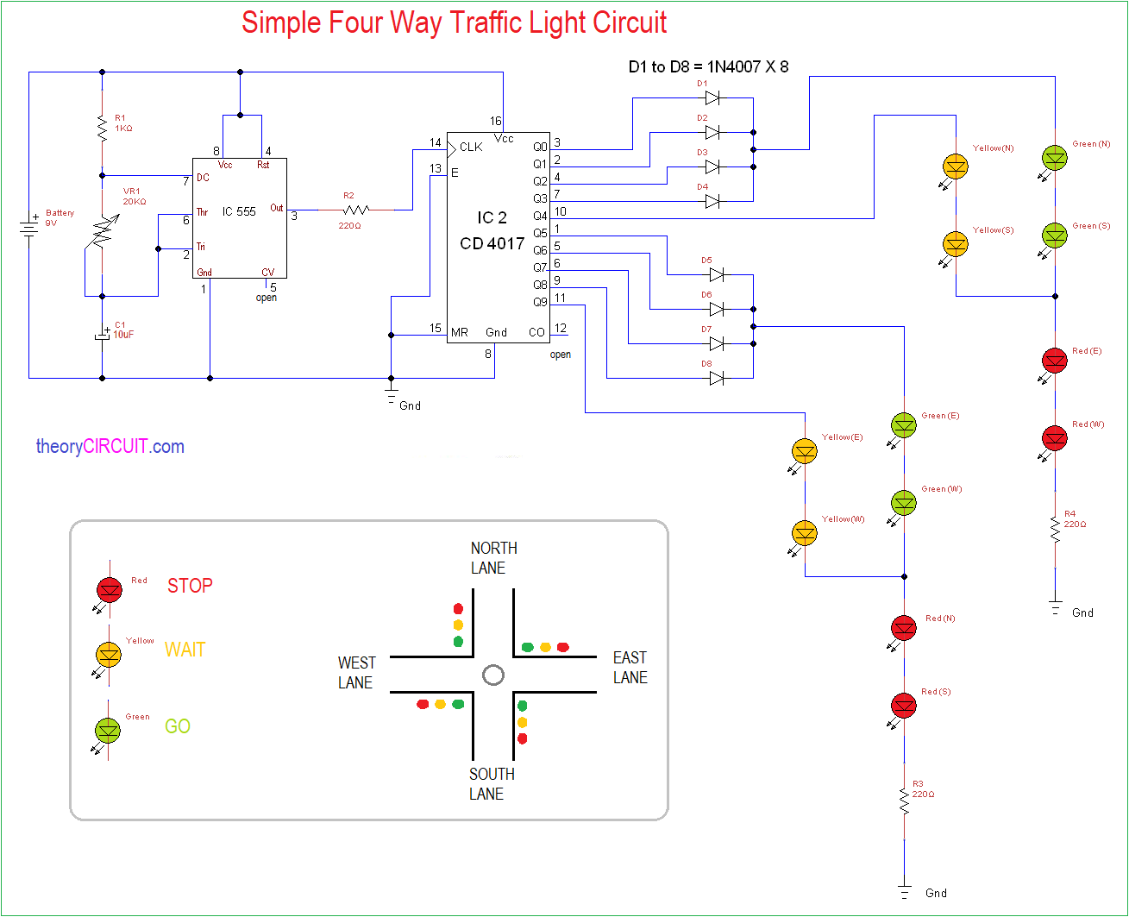

Four way **traffic light circuit diagram using 555 Timer IC** is shown in the above diagram. The timer here generates pulses of time period 100ms approximately. So the ON time is 50ms and OFF time is 50ms. This time duration can be changed by changing the capacitor value. Although street lights have a shift time for 2minutes, here we are reducing the time for testing the circuit.

The time shift for a**four way traffic light**can be achieved in this circuit by replacing the 10uF capacitor with a 470uF one. Once the power is tune ON, the timer acts as a square wave generator and generates clock, this clock is fed to the DECADE BINARY COUNTER. Now the decade binary counter counts the number of pulses given at the clock and lets the corresponding pin output go high, for example, if the event count is 3 then Q2 pin of counter will be high and if 5 is count the pin Q4 will be high. So for every 100ms there will be a peak, with this peak the counter memory gains by one and so is the output.

The diodes here prevent the shorting of counter outputs, say if the count is two with this the Q1 will be high (since Q1 is high all other outputs will be low including Q0, Q2) in the absence of diodes, Q1 with positive voltage gets hardly pulled down to LOW by Q0 (as Q0 voltage be +0V when Q1 is high), as they are connected together. With this short circuit takes place.

So during Q0, Q1, Q2, Q3 high the GREEN LED on NORTH and SOUTH will be ON along with RED LED on EAST and WEST. So if we assume clock is of 1Hz, the NORTH and SOUTH side are signaled GREEN to go for four sec and also the EAST and WEST side are signaled RED to STOP during this time.

When Q4 goes high, the YELLOW LED on NORTH and SOUTH will be ON along with RED LED on EAST and WEST. So if we assume clock is of 1Hz, the NORTH and SOUTH side are signaled YELLOW to slow down for 1sec and also the EAST and WEST side are signaled RED to STOP during this time.

When Q5, Q6, Q7, Q7 high the GREEN LED on EAST and WEST will be ON along with RED LED on NORTH and SOUTH. So if we assume clock is of 1Hz, the EAST and WEST side are signaled GREEN to go for four sec and also the NORTH and SOUTH side are signaled RED to STOP during this time.

When Q4 goes high, the YELLOW LED on EAST and WEST will be ON along with RED LED on NORTH and SOUTH. So if we assume clock is of 1Hz, the EAST and WEST side are signaled YELLOW to slow down for 1sec and also the NORTH and SOUTH side are signaled RED to STOP during this time.

These above four stages form a continuous cycle, to control the traffic light on a four way.